Project Design Phase-II
Data Flow Diagram & User Stories
Date | 03 October 2026
Developer / Student | Vinay Krishna A K
Project Name | Automated Network Request Management in ServiceNow

- Data Flow Diagram (DFD)

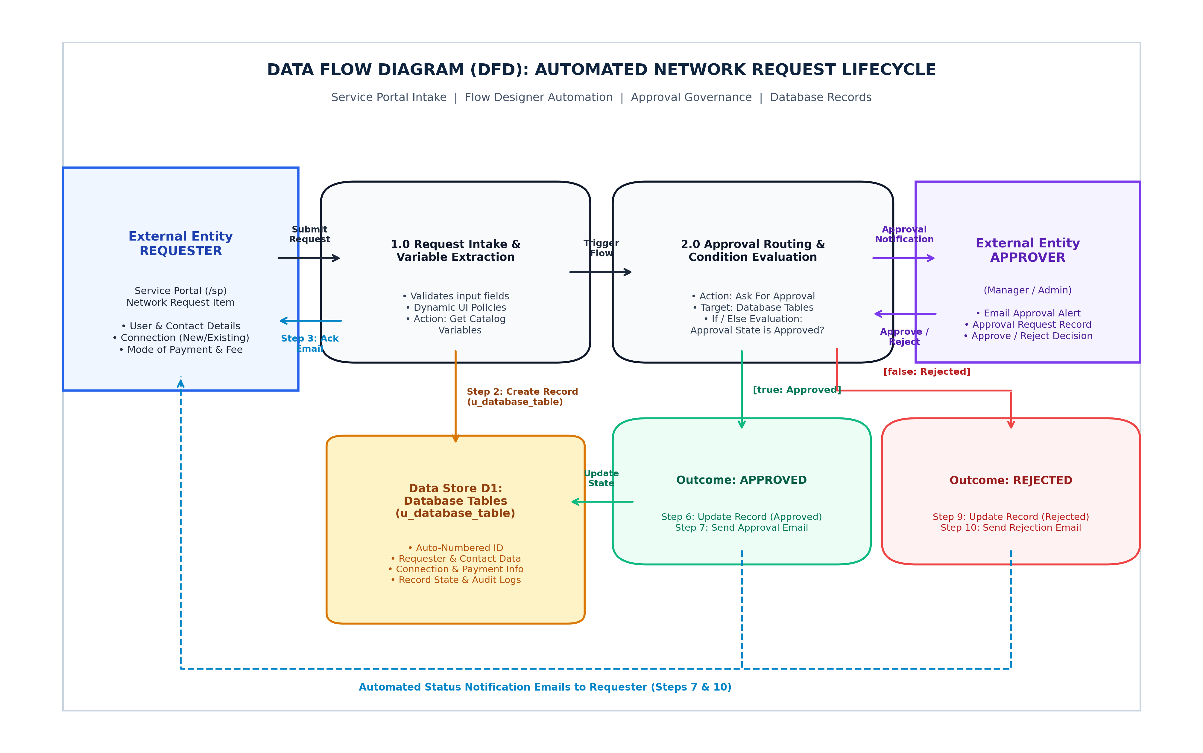

Data Flow Description (ServiceNow Implementation):
- Step 1 (Ingestion): The Requester submits the 'Network Request' catalog item via Service Portal (/sp) with User Name, Phone, Email, Mobile, Connection Type (New/Existing), Total Amount, Payment Mode (UPI/Card), and Address.
- Step 2 & 3 (Trigger & Record Creation): Service Catalog trigger runs Flow Designer. Step 1 gets catalog variables, Step 2 creates a new record in Database Tables (u_database_table), and Step 3 sends an acknowledgment email to the requester.
- Step 4 (Approval Execution): Step 4 executes 'Ask For Approval' on the newly created Database Tables record and notifies the designated approver.
- Step 5 to 7 (Approved Branch): If approved (true), Step 6 updates the Database Tables record status to Approved, and Step 7 sends an approval confirmation email to the requester.
- Step 8 to 10 (Rejected Branch): If rejected (false), Step 9 updates the Database Tables record status to Rejected, and Step 10 sends a rejection notification email to the requester.

- User Stories & Acceptance Criteria

User Type | Functional Requirement (Epic) | User Story Number | User Story / Task | Acceptance Criteria | Priority | Release
Requester (User) | Service Portal Intake | USN-01 | As a user, I want to submit a network request form on the Service Portal (/sp) so that I can request a new or existing network connection. | Network Request catalog item opens on /sp with contact, payment, and connection fields. | High | Sprint-1
Requester (User) | Dynamic Form Display | USN-02 | As a user, I want the form to dynamically adjust based on connection and device choices so that I only fill out relevant fields. | UI policy reveals connection details based on selection (New vs Existing) and device details. | High | Sprint-1
Requester (User) | Submission Acknowledgment | USN-03 | As a user, I want to receive an acknowledgment email right after submitting so that I know my request has been received. | Step 3 of Flow Designer sends an email with the submitted details and confirmation. | High | Sprint-1
Approver (Manager) | Approval Routing | USN-04 | As an approver, I want to receive approval notifications with complete request parameters so that I can approve or reject the request. | Flow Step 4 triggers 'Ask For Approval' on the created Database Tables record. | High | Sprint-2
Requester (User) | Approval Outcome Alert | USN-05 | As a user, I want to be notified by email when my request is approved or rejected so that I know the outcome. | True branch executes Step 7 (Approval Email); false branch executes Step 10 (Rejection Email). | High | Sprint-2
Administrator | Data Architecture | USN-06 | As an administrator, I want request inputs stored directly into 'Database Tables' (u_database_table) so that records are maintained cleanly. | Step 2 creates a new record in u_database_table with Auto-Numbering. | High | Sprint-1
Administrator | Automated State Updates | USN-07 | As an administrator, I want the record state in Database Tables to update automatically on approval or rejection without manual editing. | Step 6 sets state to Approved; Step 9 sets state to Rejected automatically. | Medium | Sprint-2
Administrator | Low-Code Maintainability | USN-08 | As an administrator, I want workflows built entirely via Flow Designer so that I can easily debug execution logs without custom scripts. | Flow Execution Details show step-by-step progress, condition checks, and email logs. | Medium | Sprint-2

